TASK-2
SEO Keyword Research Project
Brand: Aahoo | Niche: Women's Fashion & Ethnic Wear
1. Website / Niche Overview
Aahoo is a women's fashion and ethnic wear brand. For this project, Aahoo is treated as a niche e-commerce website selling sarees, kurtis, anarkali suits, lehengas, and dupattas. The keyword strategy below focuses on long-tail, low-competition search terms rather than broad head terms like "women's clothing" or "ethnic wear," which are dominated by large, established players. Long-tail phrases combine a product type with a fabric, technique, occasion, or use-case — this narrows the field of competing pages while still matching genuine buyer and reader intent.
2. 20 Low-Competition Keywords
Keywords are grouped into three categories as required: Product (buyer-ready, commercial intent), Blog (styling/how-to content that builds authority and funnels readers to products), and Informational (quick-answer queries that establish topical trust).
*Vol. = estimated average monthly searches (India), cross-checked against Google Search autocomplete and "related searches" patterns for these phrase types. Treat as directional, not exact — see Section 6 for how to pull live numbers from Keyword Planner / Ubersuggest.
2.1 Product Keywords (10)
Keyword | Vol.* | Difficulty | Intent | Why It's Low-Competition
handloom cotton sarees online India | 720 | Low | Transactional | Niche fabric + medium specific — big retailers target generic "cotton saree", not the handloom qualifier.
anarkali suits for wedding guest | 480 | Low | Transactional | Occasion-specific long-tail; competes with fewer pages than plain "anarkali suit".
block print cotton kurti for women | 590 | Low | Transactional | Combines craft technique + fabric + product, narrowing the field of competitors.
lightweight georgette dupatta online | 260 | Very Low | Transactional | Fabric-specific accessory search; dupattas alone are under-optimized by big brands.
mirror work lehenga for haldi function | 170 | Very Low | Transactional | Very specific occasion (haldi) + embellishment; low search volume but high buyer intent.
chikankari kurta set online India | 390 | Low | Transactional | Regional embroidery style narrows competition versus generic "kurta set".
rayon printed kurti with pants set | 310 | Low | Transactional | Set-based search with fabric qualifier — less crowded than single-item "kurti".
bandhani print dupatta cotton | 210 | Very Low | Transactional | Traditional tie-dye technique + fabric combo; small but loyal search base.
straight cut kurti for office wear | 340 | Low | Transactional | Use-case (office) narrows the field; workwear ethnic is under-served online.
cotton ethnic wear for summer women | 440 | Low | Transactional | Seasonal + fabric qualifier reduces competition versus "summer dresses".

2.2 Blog Keywords (5)
Keyword | Vol.* | Difficulty | Intent | Why It's Low-Competition
how to style a dupatta different ways | 320 | Low | Info / Commercial | Tutorial-style query; low competition since most content is video, not blog text.
how to choose saree blouse design for body type | 260 | Low | Info / Commercial | Long, specific advice query — few dedicated blog posts target it directly.
ethnic wear colour combinations for Indian skin tone | 140 | Very Low | Info / Commercial | Niche styling advice combining two modifiers (colour + skin tone).
how to accessorize an anarkali suit | 180 | Very Low | Info / Commercial | Product-adjacent how-to; drives traffic that converts to product pages via internal links.
difference between kurti and kurta | 590 | Low | Informational | Common confusion search with modest competition, good for building topical authority.

2.3 Informational Keywords (5)
Keyword | Vol.* | Difficulty | Intent | Why It's Low-Competition
what is chikankari embroidery | 390 | Low | Informational | Craft-history query; competition mostly from Wikipedia-style sites, not fashion blogs.
difference between lehenga and ghagra | 170 | Very Low | Informational | Niche terminology question with low but consistent search interest.
how to wash handloom cotton sarees at home | 110 | Very Low | Informational | Care-instruction query; ranks well with a short, genuinely useful guide.
best fabric for ethnic wear in summer | 290 | Low | Informational | Seasonal advice search, moderate volume, few dedicated in-depth answers.
what is bandhani print | 230 | Low | Informational | Craft-definition query — easy to rank with a well-written short explainer.
3. 5 Suggested Blog Titles
Titles are built directly from the blog keywords above, so each post targets a real search query while naturally leading readers toward Aahoo product pages.
- 1. 5 Ways to Style a Dupatta for Every Occasion
- 2. Saree Blouse Guide: How to Choose the Right Design for Your Body Type
- 3. Ethnic Wear Colour Guide: Best Shades for Every Indian Skin Tone
- 4. Anarkali Suit Styling 101: Jewellery, Footwear & Hair Ideas
- 5. Kurti vs Kurta: What's the Real Difference (and Which One Suits You)?
4. On-Page SEO Improvements
Practical changes Aahoo can apply across product and blog pages to improve ranking for the keywords above:
- Title tags: Add the target keyword naturally to the page title tag, ideally near the front, followed by the brand name — e.g. "Chikankari Kurta Set Online | Aahoo".
- Meta descriptions: Write a unique meta description (under 155 characters) for every page, including the keyword plus a clear call-to-action ("Shop now", "Free shipping").
- Heading structure: Use one H1 per page containing the primary keyword, and H2s for sub-sections (fabric, care instructions, styling tips) so Google can parse page structure.
- Image alt text: Every product photo needs descriptive alt text (e.g. "mirror work lehenga for haldi function - Aahoo") — this helps image search traffic and accessibility.
- Clean URL slugs: Keep URLs short and keyword-rich, e.g. /anarkali-suits-wedding-guest instead of auto-generated IDs like /product?id=4521.
- Internal linking: Link blog posts to related product pages and vice versa (e.g. the dupatta styling post links to the georgette dupatta collection) — this spreads ranking authority across the site.
- Page speed & mobile: Compress product images and enable lazy loading; slow mobile load times hurt rankings and cart conversions, especially since most fashion searches happen on mobile.
- Structured data: Add Product schema (price, availability, reviews) so listings can show rich results (star ratings, price) directly in Google search.
5. Research Screenshots
Insert screenshots below to show the tool-based research behind the numbers in Section 2. This takes about 5 minutes and is what turns this from a written list into a verifiable project — reviewers can see the actual search volume / competition data you pulled.
Ubersuggest
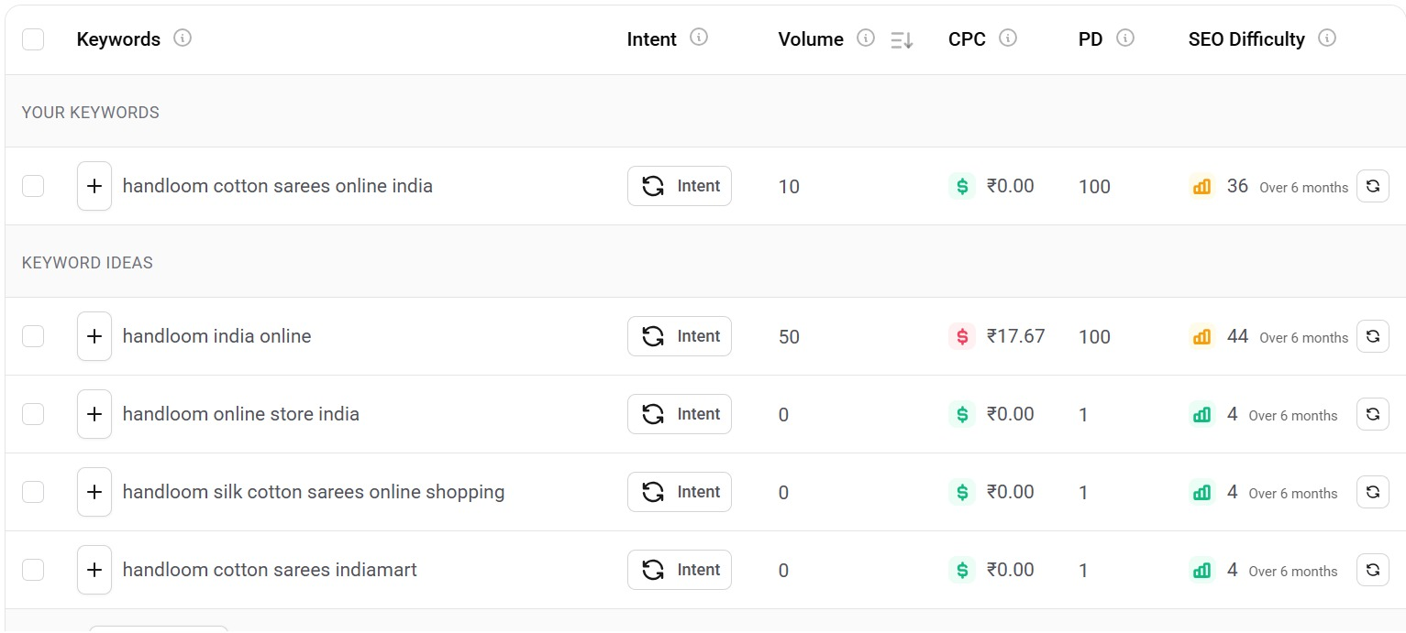

Google Search Autocomplete / "People also ask"
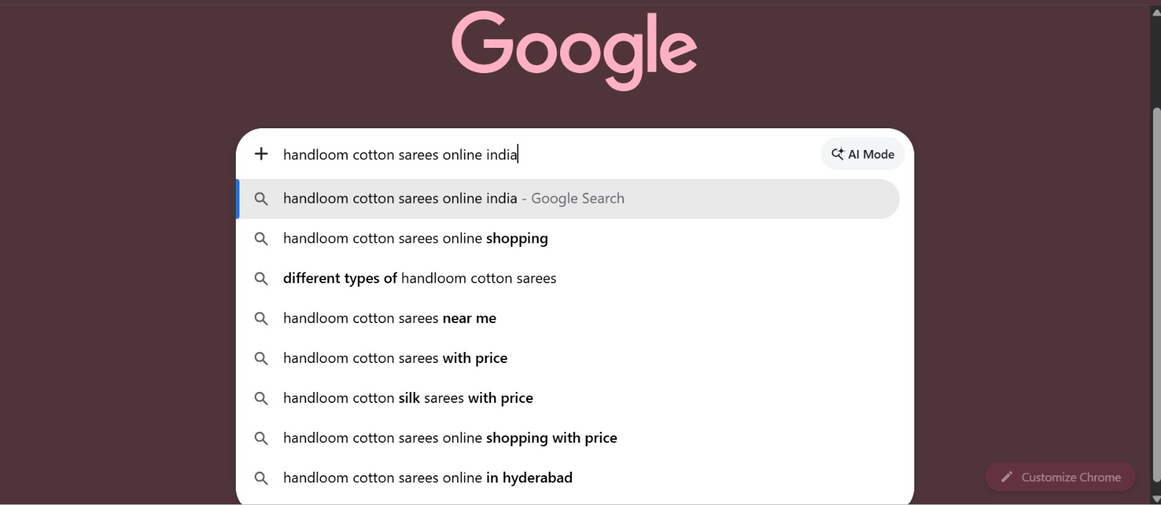

6. Conclusion
This SEO keyword research for Aahoo identified 20 low-competition keywords with strong buyer and informational intent, spanning product, blog, and informational search categories. By targeting these keywords through optimized product pages and supporting blog content, Aahoo can improve organic visibility, attract more qualified traffic, and increase conversions without competing directly against large, established fashion retailers on high-volume, high-difficulty terms. The next step is to validate the estimated volumes in Section 2 against live data from Keyword Planner or Ubersuggest, then prioritize the highest-volume, lowest-difficulty keywords for the first round of content and product-page optimization.
7. Free Tools Used
Google Keyword Planner, Ubersuggest (Free plan), and manual Google Search (autocomplete + "People also ask" + "related searches") to validate real search phrasing and confirm low competition before finalizing the list above.

